# **Problems #26 to #30**

=======================================

# **Problem 26**

====================

Description:Write A Program to:Print Numbers From 1 to N

==========================================

#include <iostream>

using namespace std;

int ReadNumbers(){

int N = 0;

cout<<"Enter The Number: ";

cin>> N;

return N;

}

void PrintRangeFrom1TNUsingForLoop(int N){

for(int i = 1; i <=N; i++){

cout<<i<<" ";

}

}

int main() {

int N = ReadNumbers();

PrintRangeFrom1TNUsingForLoop(N);

return 0;

}

=====================================================================

The Output:

===========

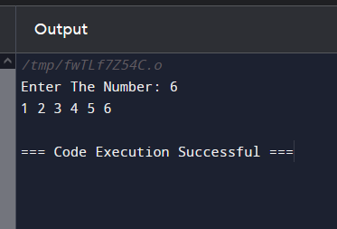

=====================================================================

# **Problem 27**

====================

Description:Print Numbers From N To 1;

=============================

#include <iostream>

using namespace std;

int ReadNumbers(){

int N = 0;

cout<<"Enter The Number: ";

cin>> N;

return N;

}

void PrintRangeFromNTo1UsingForLoop(int N){

cout<<"\n============================\n";

for(int i = N; i >= 1; i--){

cout<<i<<" ";

}

cout<<"\n============================"<<endl;

}

int main() {

int N = ReadNumbers();

PrintRangeFromNTo1UsingForLoop(N);

return 0;

}

=====================================================================

The Output:

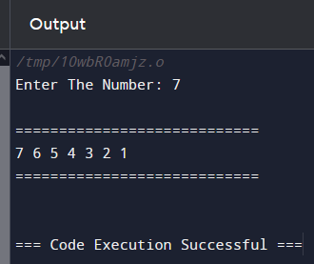

=====================================================================

# **Problem 28**

===================

Description: Sum odd Numbers From 1 To N;

=================================

#include <iostream>

using namespace std;

enum enOddOrEven { Odd = 1, Even = 2};

int ReadNumbers(){

int N = 0;

cout<<"Enter The Number: ";

cin>> N;

return N;

}

enOddOrEven CheckOddOrEven(int Number){

if(Number % 2 == 1)

return enOddOrEven::Odd;

else

return enOddOrEven::Even;

}

void SumOddNumbersFrom1ToN_UsingFor(int Number){

cout<<"\nThe Sum Of Odd Using For Loop"<<endl;

cout<<"\n============================\n";

int sum = 0;

for(int i = 1; i <= Number; i++){

if(CheckOddOrEven(i) == enOddOrEven::Odd){

sum += i;

}

}

cout<<"\nThe Sum Of Odd Number Is: "<<sum<<endl;

cout<<"\n============================"<<endl;

}

void SumOddNumbersFrom1ToN_UsingWhile(int Number){

cout<<"\nThe Sum Of Odd Using While"<<endl;

cout<<"\n============================\n";

int sum = 0;

int i = 0;

while(i < Number){

i++;

if(CheckOddOrEven(i) == enOddOrEven::Odd){

sum += i;

}

}

cout<<"\nThe Sum Of Odd Number Is: "<<sum<<endl;

cout<<"\n============================"<<endl;

}

void SumOddNumbersFrom1ToN_UsingDo(int Number){

cout<<"\nThe Sum Of Odd Using Do While"<<endl;

cout<<"\n============================\n";

int sum = 0;

int i = 0;

do{

if(CheckOddOrEven(i) == enOddOrEven::Odd){

sum += i;

}

i++;

}while(i <= Number);

cout<<"\nThe Sum Of Odd Number Is: "<<sum<<endl;

cout<<"\n============================"<<endl;

}

int main() {

int Number = ReadNumbers();

SumOddNumbersFrom1ToN_UsingWhile(Number);

SumOddNumbersFrom1ToN_UsingFor(Number);

SumOddNumbersFrom1ToN_UsingDo(Number);

return 0;

}

=====================================================================

The Output:

===========

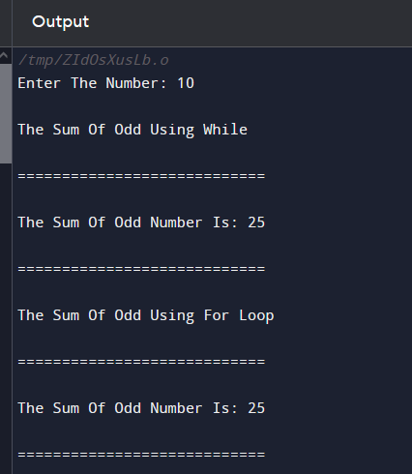

=====================================================================

# **Problem 29**

=====================

Description: Write A Program: Sum Even Numbers From 1 To N;

===============================================

#include <iostream>

using namespace std;

enum enOddOrEven { Odd = 1, Even = 2};

int ReadNumbers(){

int N = 0;

cout<<"Enter The Number: ";

cin>> N;

return N;

}

enOddOrEven CheckOddOrEven(int Number){

if(Number % 2 == 0)

return enOddOrEven::Even;

else

return enOddOrEven::Odd;

}

void SumEvenNumbersFrom1ToN_UsingFor(int Number){

cout<<"\nThe Sum Of Even Using For Loop"<<endl;

cout<<"\n============================\n";

int sum = 0;

for(int i = 1; i <= Number; i++){

if(CheckOddOrEven(i) == enOddOrEven::Even){

sum += i;

}

}

cout<<"\nThe Sum Of Even Number Is: "<<sum<<endl;

cout<<"\n============================"<<endl;

}

void SumEvenNumbersFrom1ToN_UsingWhile(int Number){

cout<<"\nThe Sum Of Even Using While"<<endl;

cout<<"\n============================\n";

int sum = 0;

int i = 0;

while(i < Number){

i++;

if(CheckOddOrEven(i) == enOddOrEven::Even){

sum += i;

}

}

cout<<"\nThe Sum Of Even Number Is: "<<sum<<endl;

cout<<"\n============================"<<endl;

}

void SumEvenNumbersFrom1ToN_UsingDo(int Number){

cout<<"\nThe Sum Of Even Using Do While"<<endl;

cout<<"\n============================\n";

int sum = 0;

int i = 0;

do{

if(CheckOddOrEven(i) == enOddOrEven::Even){

sum += i;

}

i++;

}while(i <= Number);

cout<<"\nThe Sum Of Even Number Is: "<<sum<<endl;

cout<<"\n============================"<<endl;

}

int main() {

int Number = ReadNumbers();

SumEvenNumbersFrom1ToN_UsingWhile(Number);

SumEvenNumbersFrom1ToN_UsingFor(Number);

SumEvenNumbersFrom1ToN_UsingDo(Number);

return 0;

}

=====================================================================

The OutPut:

===========

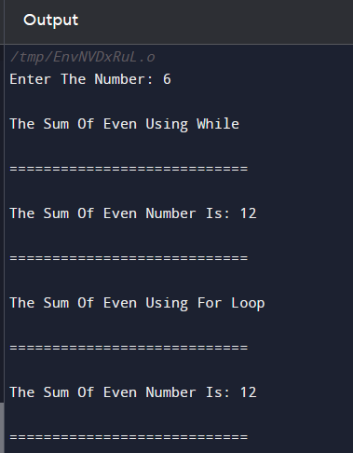

=====================================================================

# **Problem 30**

==================

Description:Write A Program: Factorial Of N;

==================================

#include <iostream>

using namespace std;

int ReadPositiveNumber(string Message){

int Number;

do{

cout<<Message;

cin>> Number;

}while(Number < 0);

return Number;

}

int Factorial(int N){

int F = 1;

for(int i = N; i >= 1; i--){

F = F * i;

}

return F;

}

void PrintResult(int result){

cout<<"The Factorial Is: "<<result<<endl;

}

int main() {

cout<<Factorial(ReadPositiveNumber("Enter Positive Number: "));

return 0;

}

=====================================================================

The Output:

=========



